# MIS 275 - Lab 8

You will need to complete this lab by using SQL Server Management Studio. Use your textbook, in class activity and lecture as resources for help in completing the lab. Once you have completed the assignment then upload it to Canvas. Save your document with the following naming convention:

* Course_Lab Number_First Initial Last Name (Example: MIS275_Lab8_LStewart.docx)

Complete My Guitar Shop Murach Chapter 8 Exercises

1. Write a SELECT statement that returns these columns from the Products table:

The ListPrice column

A column that uses the CAST function to return the ListPrice column with 1 digit to the right of the decimal point

A column that uses the CONVERT function to return the ListPrice column as an integer

A column that uses the CAST function to return the ListPrice column as an integer

Paste a screen print of the SQL statement and the resulting data set below.

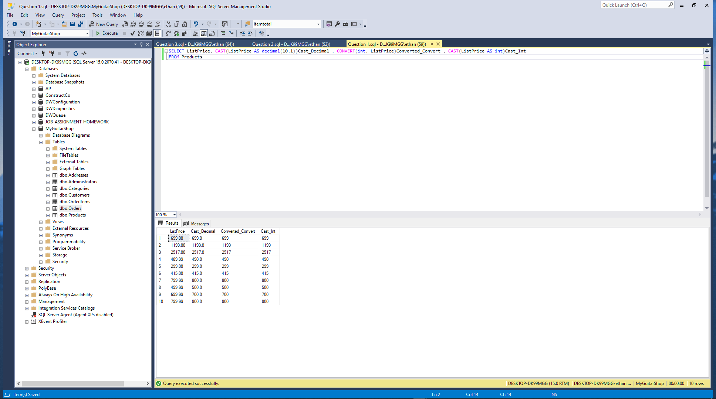

1. Write a SELECT statement that returns these columns from the Products table:

The DateAdded column

A column that uses the CAST function to return the DateAdded column with its date only (year, month, and day)

A column that uses the CAST function to return the DateAdded column with its full time only (hour, minutes, seconds, and milliseconds)

A column that uses the CAST function to return the DateAdded column with just the month and day

Paste a screen print of the SQL statement and the resulting data set below.

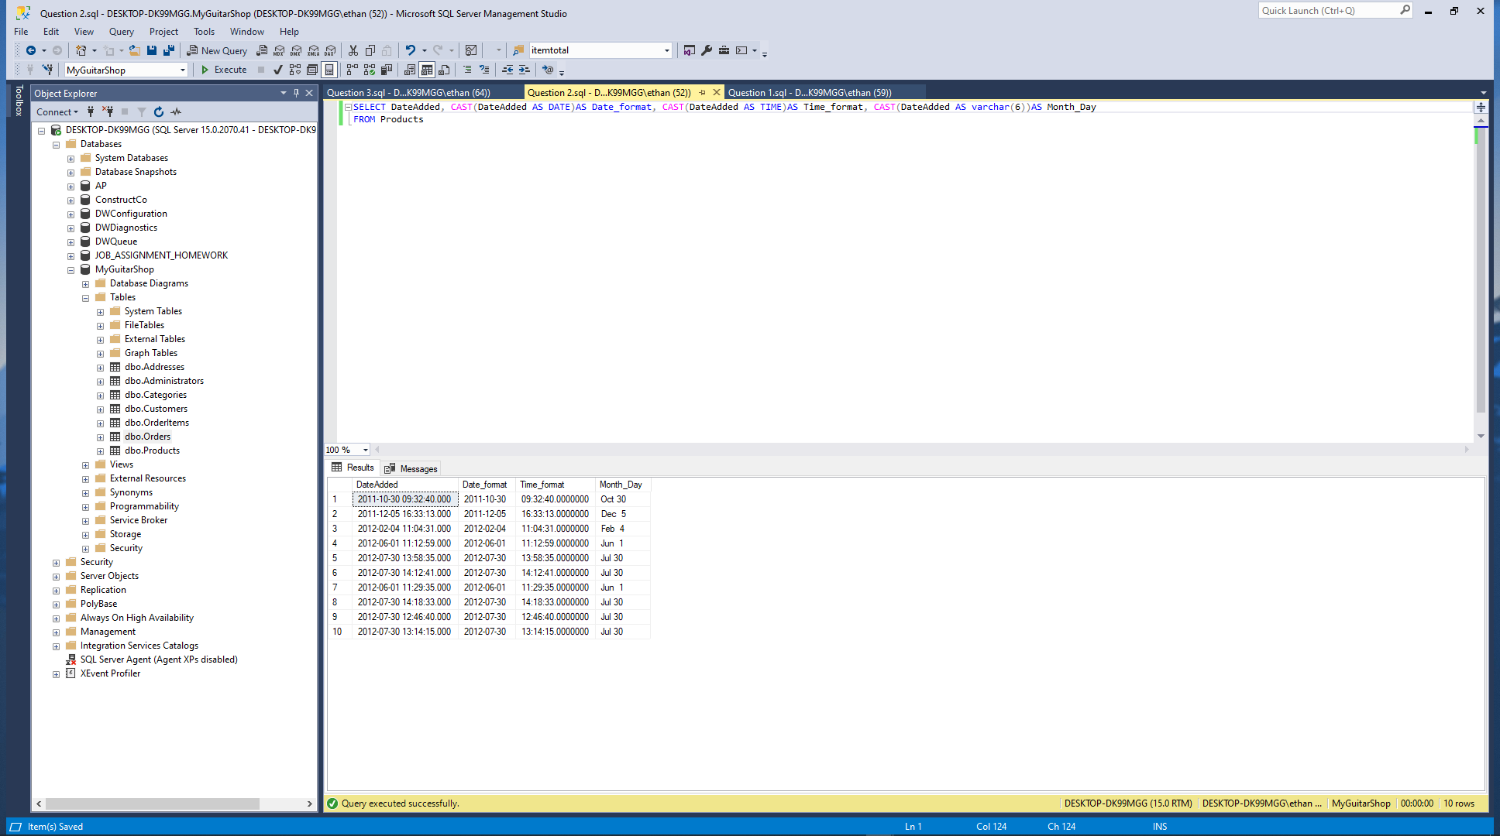

1. Write a SELECT statement that returns these colums from the Orders table:

A column that uses the CONVERT function to return the OrderDate column in this format: MM/DD/YYYY. In other words, use two-digit months, days, and years and separate each date component with slashes

A column that uses the CONVERT function to return the OrderDate column with the date, and the hours and minutes on a 12-hour clock with an am/pm indicator

A column that uses the CONVERT function to return the OrderDate column with 2-digit hours, minutes, and seconds on a 24-hour clock. Use leading zeros for all date/time components.

Paste a screen print of the SQL statement and the resulting data set below.

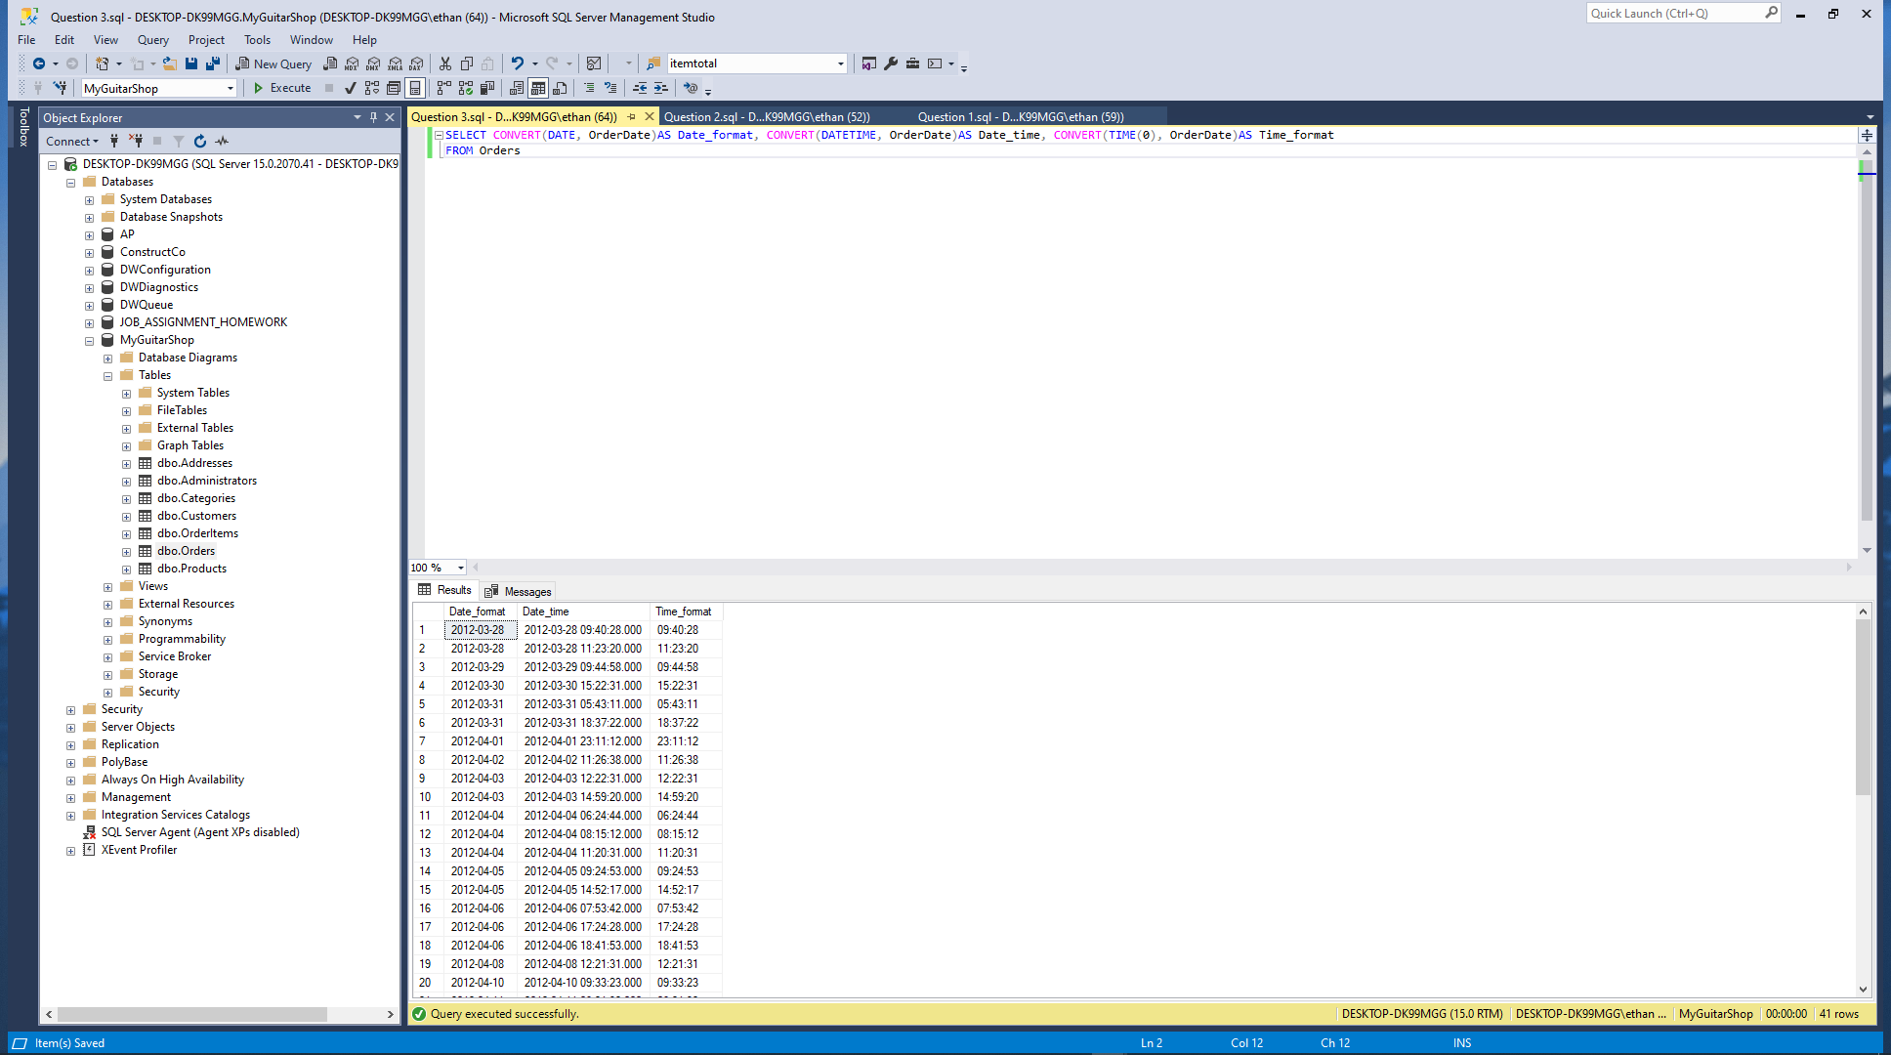

Complete Problems 1, 2, 3, 5 Chapter 8 Cengage Pg. 418-420

For these problems, you’ll enter and run your SQL statements. In addition to providing screen prints, create a SQL script file that contains your SQL statements. Once you’ve completed this lab, zip this Word document with your answers and your script file and upload the zipped file to the designated link in Canvas.

For these exercises your will need to **create a database named ‘CH08_SimpleCo’** to complete the exercise questions. Use red font when answering your question.

Number each problem and paste a screen print of the SQL statement and the resulting data set.

1. 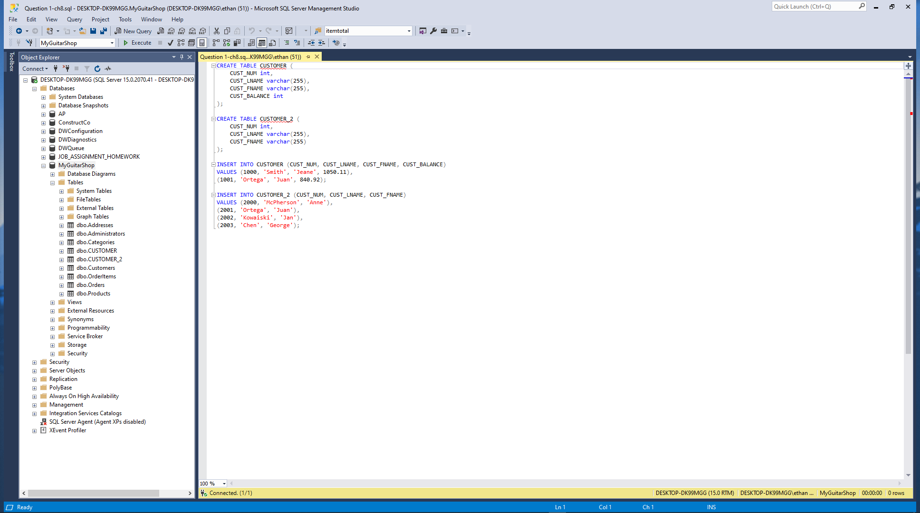

2. 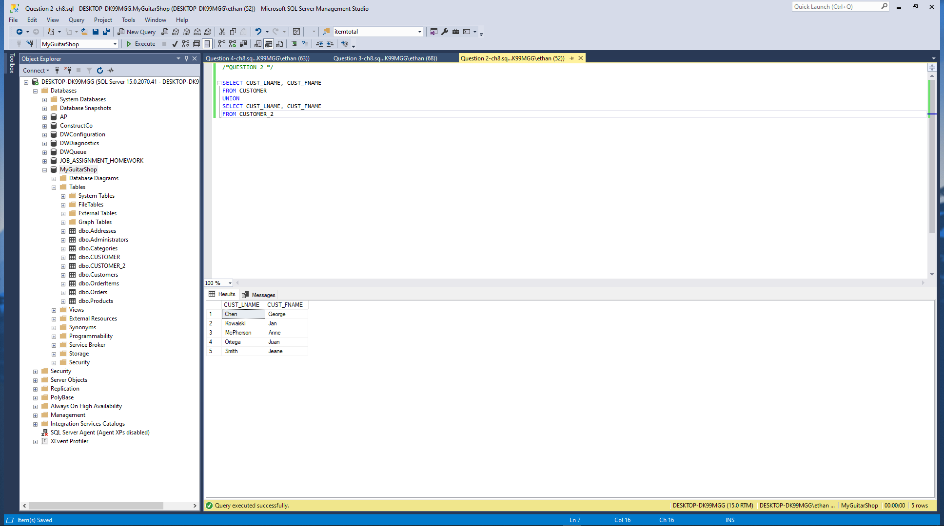

3. 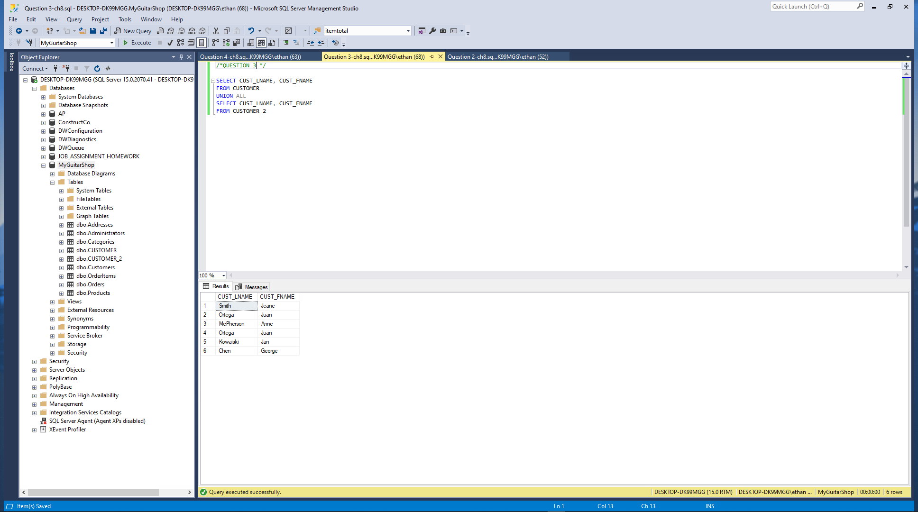

5. 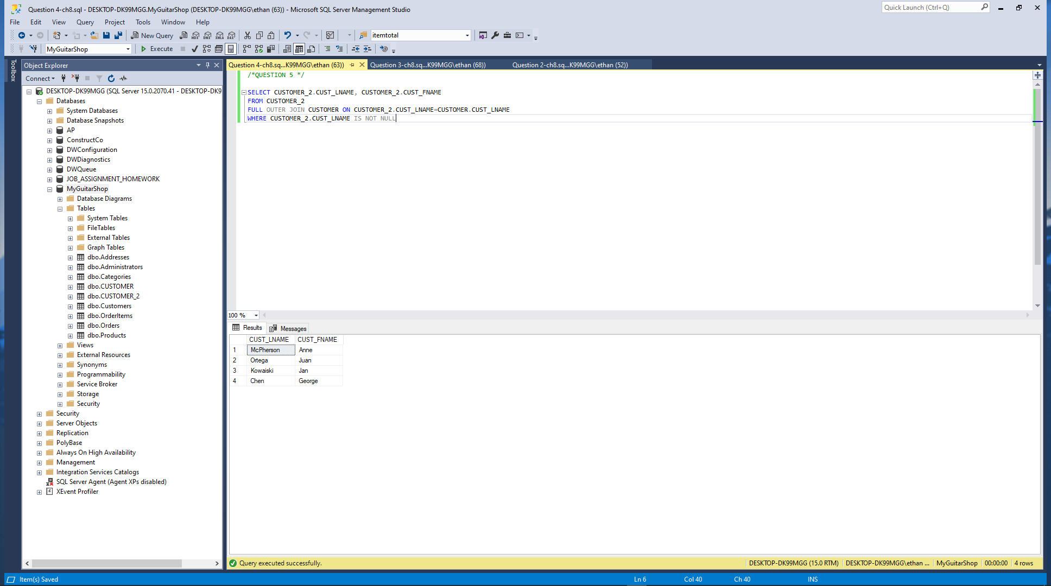

When you are finished zip this Word document with your answers AND your script files then zip file then upload to the designated link in Canvas.